Project 2

Aleksandr Donovan
SNHU
CS 340: Client/Server development
Sean Morris
04/13/2026

Purpose of the project
This is a Python-based web application dashboard developed for Grazioso Salvare. The goal was to create a client-facing interface that would allow users to interact with and visualize animal shelter data stored in a MongoDB database. Developed using CRUD database operations to display and filter the data. The dashboard connects the Austin Animal Center (AAC) database and then works with the animal collection to retrieve animal records.
Grazioso Salvare required widgets for the dashboard interface to filter dogs based on rescue categories such as water rescue, mountain or wilderness rescue, and disaster or individual tracking. These filters are based on specific criteria, including breed, age, and sex, to help identify dogs that are suitable for search-and-rescue training.
In addition to filters, the dashboard also provides a geolocation map and a dynamic chart that updates in real time based on user input to demonstrate how a database can be integrated with a client-side application.

How it works
The dashboard follows the MVC design pattern. MongoDB serves as the model by storing and managing the data. The dashboard interface acts as the view, displaying the data through tables, charts, and maps. The callback functions act as the controller by handling user input, querying the database, and updating the interface.
The dashboard was built using Python and the Dash framework to create a web-based interface. It connects to the MongoDB database through the CRUD module and uses PyMongo to retrieve data from the database.
As it starts, it loads all the animal records into a data table using a “retrieve all” query. Users can then select a filter option, which then sends a query through the CRUD module to retrieve only the relevant data. The filtered results then update the data table, the chart, and the geolocation map. This demonstrates how controller logic connects user input to database queries and updates the visual components of the application.

Tools used
Several tools were used in this project to support both the backend and frontend of the application:
- Python: the main programming language to build the dashboard and handle the logic. It integrates well with both MongoDB and dash frameworks, and was chosen for that reason.
- MongoDB: MongoDB was used to store and manage the animal shelter data because it is a flexible document-based database that works well with JSON-style data. It also integrates easily with Python through PyMongo.
- PyMongo: used as the official MongoDB driver for Python, it allows the application to connect to the database and perform CRUD operations, which make it possible to retrieve and filter data for the dashboard.
- Dash: Dash was used to create the web-based dashboard interface. It allows for the development of interactive applications that update in real time based on user input, without requiring extensive frontend development.
- Plotly and Dash Leaflet: Plotly was used to create the data visualization chart, and Dash Leaflet was used to implement the geolocation map. They both integrate directly with Dash and help create visuals for users to better understand where animals are located.
- Jupyter Notebook was used to develop and test the dashboard. It provides an interactive environment for running and debugging code.
- Codio was used as the development environment to write, test, and run the project.

Steps Taken
There were several steps taken to build the final dashboard.
Step one was to set up the MongoDB database and import the Austin Animal Center dataset. Then, a database user was created with the appropriate permissions to allow access.
Next, the CRUD Python module was used to connect to the database. This module was used to retrieve data and perform queries needed for the dashboard.

Figure: CRUD Python Module
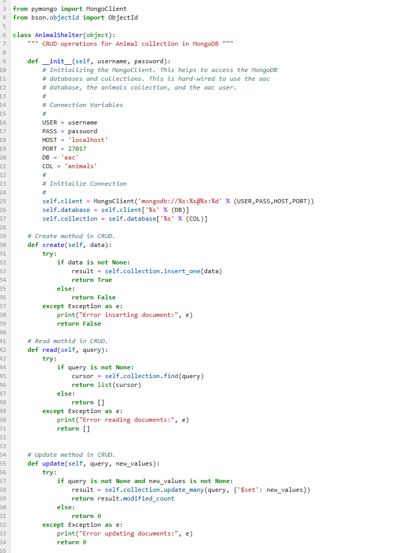
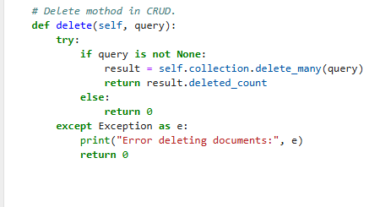
After confirming data could be successfully retrieved and displayed using an unfiltered data table, filter queries were developed based on the rescue categories provided in the project specifications. These queries were integrated into the dashboard using interactive radio button options.

Figure: Filters
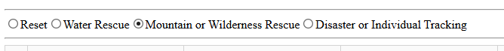

Then, the dashboard was expanded by adding a chart and a geolocation map.
Figure: Geolocation map
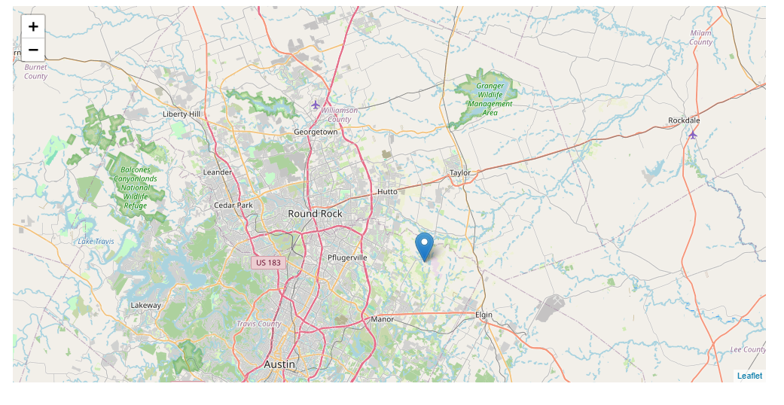
Finally, the dashboard was tested to ensure that all components function correctly. This included verifying that filters update the table, chart, and map, and confirming that the application runs without any errors.

Challenges
A few challenges encountered during this project were ensuring that filters returned accurate results. Some breeds in the dataset did not always match the expected values. This was addressed by adjusting the logic and testing to ensure the filters returned the right results.
Another challenge was handling errors within the dashboard callbacks. Certain callbacks initially caused errors when no data was selected. This was resolved by adding checks to handle cases where data was not available.
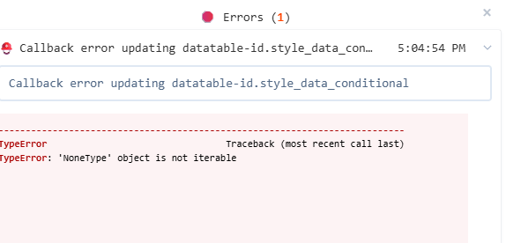

Additionally, a pie chart was initially used to visually represent the data, but became difficult to read when showing many different breed categories.
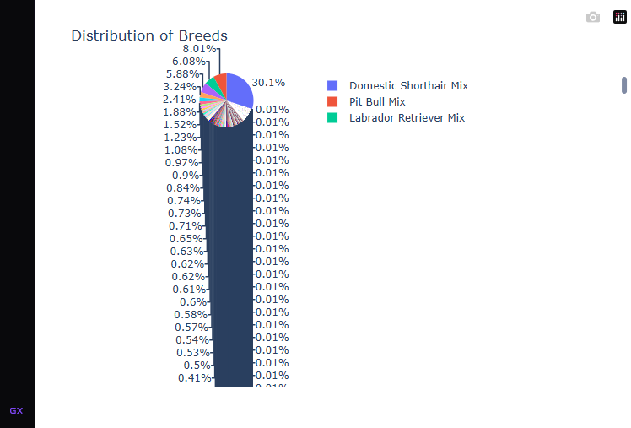

Switching to a bar chart to display the top breeds ended up making the data easier to understand and more visually clear. This resulted in a more user-friendly dashboard.
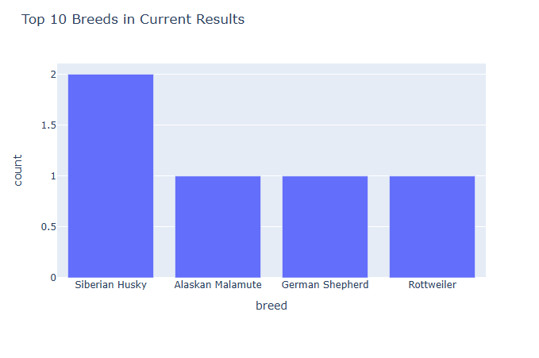

Demonstration
The dashboard was tested to ensure that all components function correctly and respond to user input. The screenshots below demonstrate the functionality of the application.
The first screenshot shows the initial unfiltered dashboard. All animal records are displayed along with the chart and map. The following screenshots show the dashboard after applying each filter option.
Figure 1: Initial Dashboard (Unfiltered)
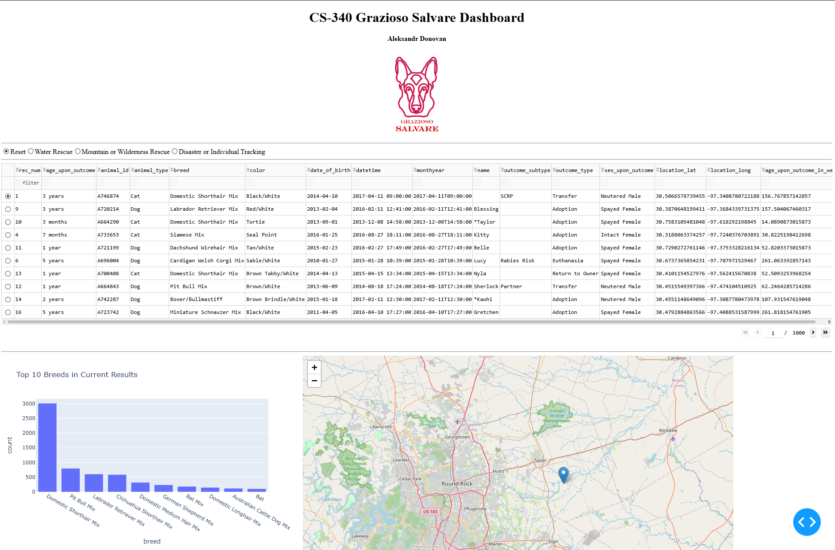
Figure 2: Water rescue filter
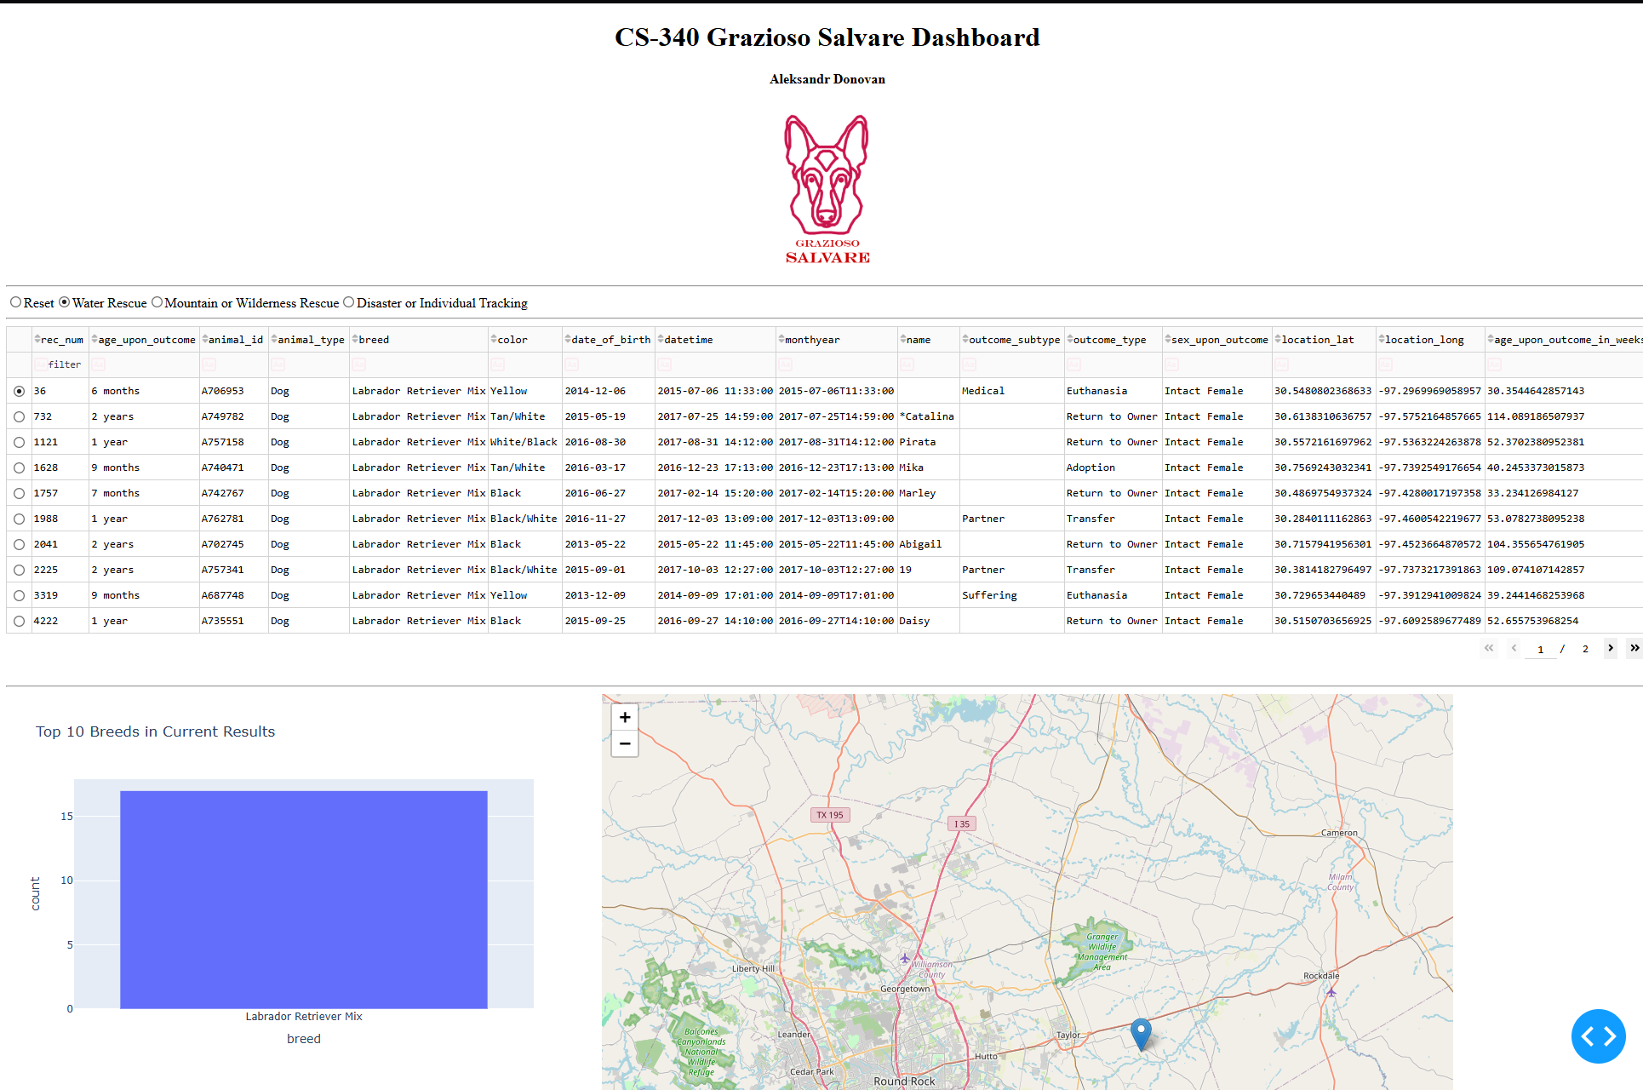

Figure 3: Mountain and wilderness filter applied
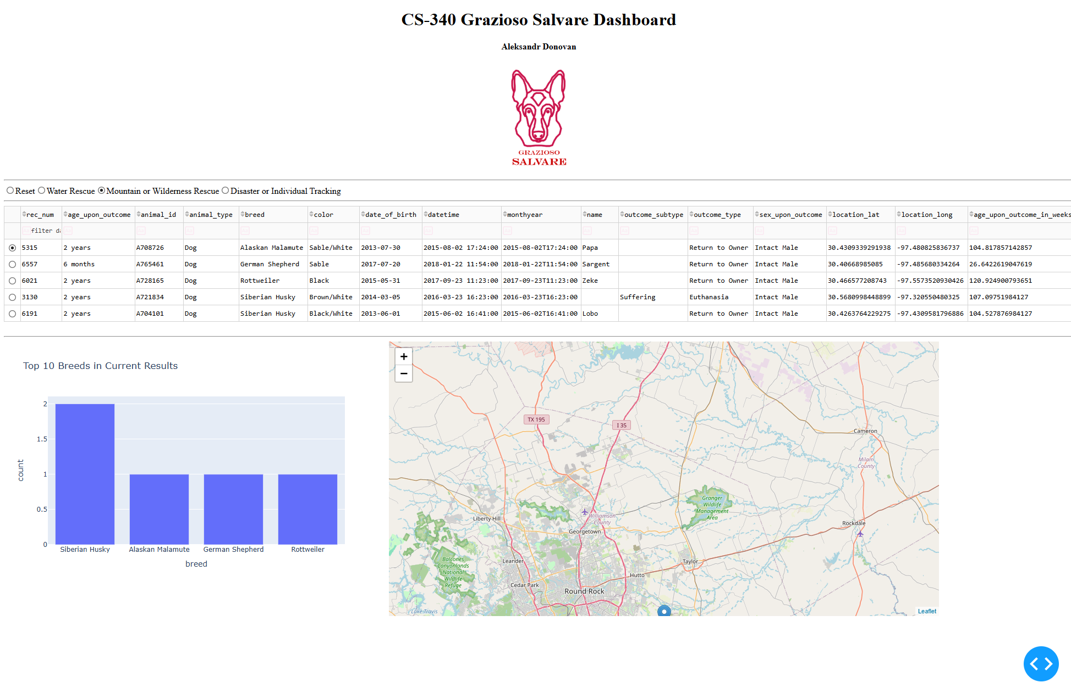

Figure 4: Disaster or Individual Tracking
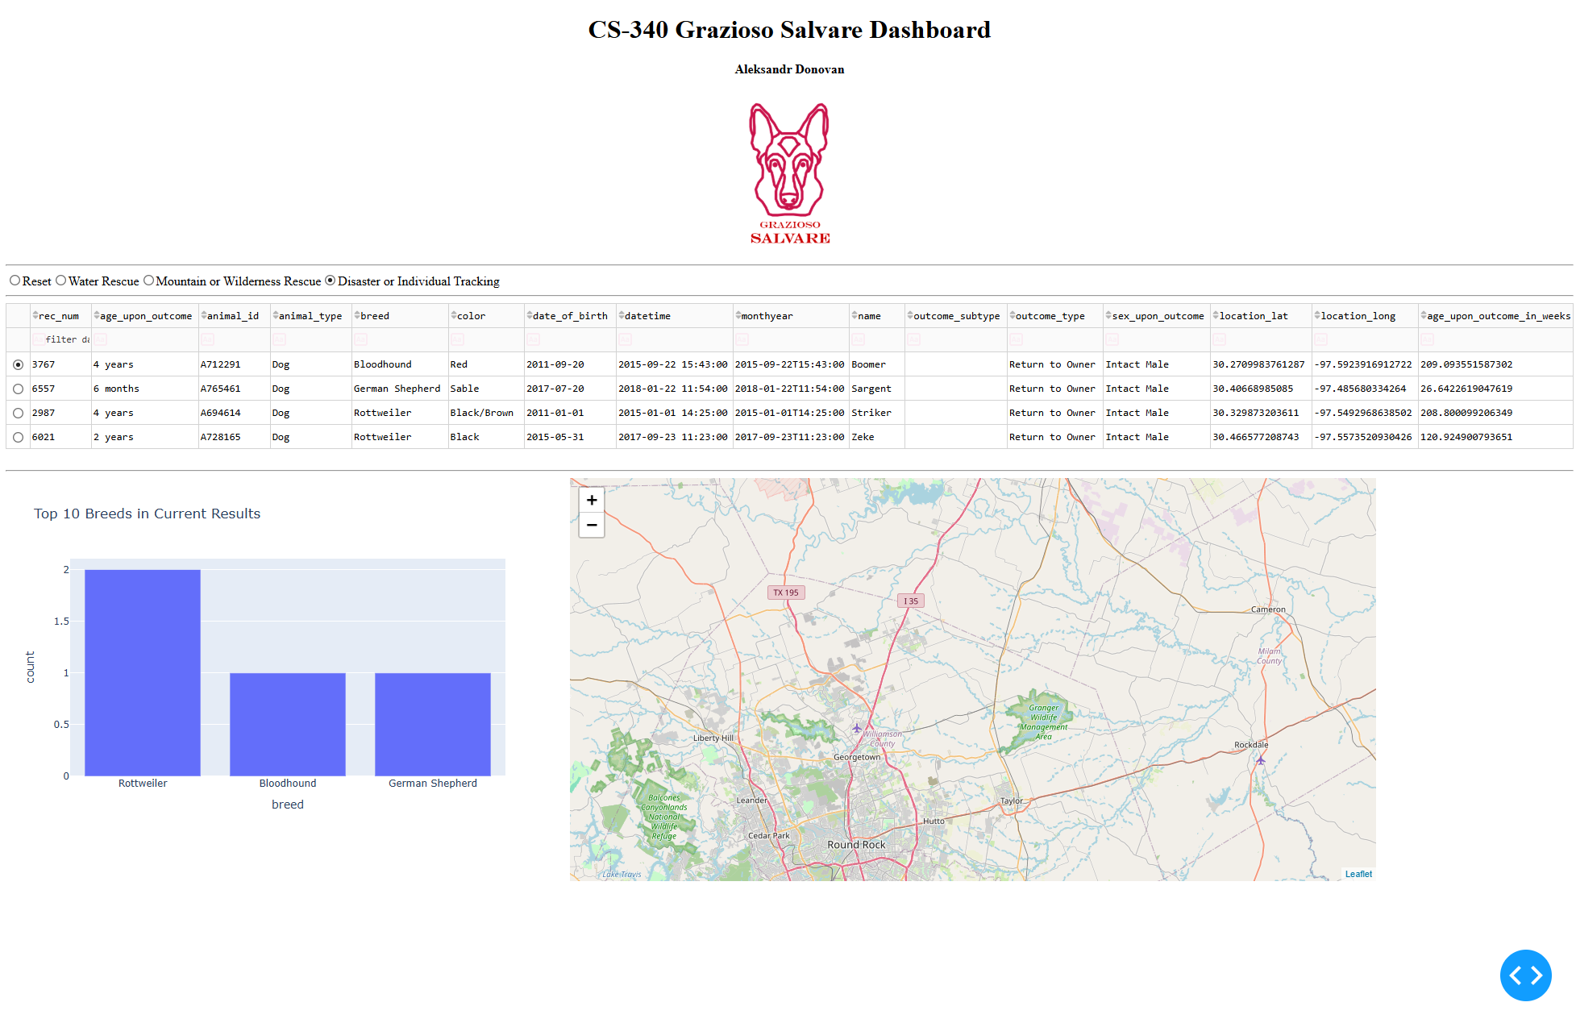

Figure 5: Reset
